Class Time:
Names:

Descriptive Statistics: Descriptive Statistics Lab I

Student Learning Outcome:
- The student will construct a histogram and a box plot.
- The student will calculate univariate statistics.
- The student will examine the graphs to interpret what the data implies.
Collect the Data
Record the number of pairs of shoes you own:
- Randomly survey 30 classmates. Record their values.
Survey Results
____ | ____ | ____ | ____ | ____
____ | ____ | ____ | ____ | ____
____ | ____ | ____ | ____ | ____
____ | ____ | ____ | ____ | ____
____ | ____ | ____ | ____ | ____
____ | ____ | ____ | ____ | ____

- Construct a histogram. Make 5-6 intervals. Sketch the graph using a ruler and pencil. Scale the axes.
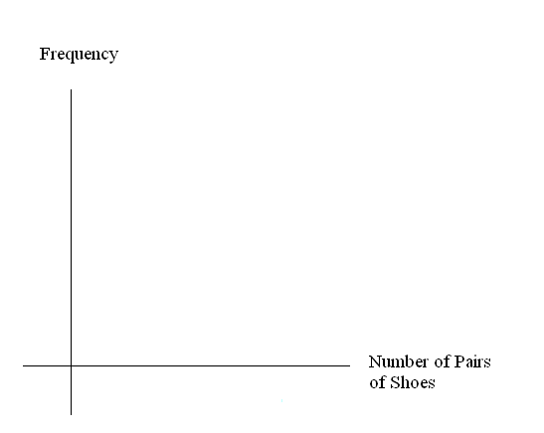
- Calculate the following:
  - =
  - s =
- Are the data discrete or continuous? How do you know?

- Describe the shape of the histogram. Use complete sentences.

- Are there any potential outliers? Which value(s) is (are) it (they)? Use a formula to check the end values to determine if they are potential outliers.

Analyze the Data
- Determine the following:
  - Minimum value =
  - Median =
  - Maximum value =
  - First quartile =
  - Third quartile =
  - IQR =
- Construct a box plot of data.

- What does the shape of the box plot imply about the concentration of data? Use complete sentences.

- Using the box plot, how can you determine if there are potential outliers?

- How does the standard deviation help you to determine concentration of the data and whether or not there are potential outliers?

- What does the IQR represent in this problem?

- Show your work to find the value that is 1.5 standard deviations:
  - Above the mean:
  - Below the mean:

